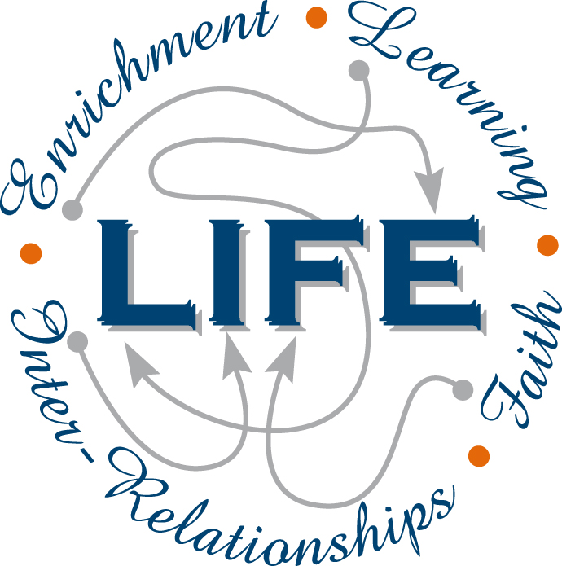
12 PHYSICS
ASSESSMENT OUTLINE 2020

Assessment type | Assessment type weighting | Assessment  task  weighting | When | Assessment task
Science  inquiry | 20% | 5% | Spring Term  Week 5 | Experiment - circular motion
 |  | 5% | Summer Term  Week 7 | Evaluation and analysis - gravitation
 |  | 5% | Winter Term  Week 2 | Experiment - line spectra
 |  | 5% | Winter Term  Week 3 | Investigation - blackbody radiation
Test | 30% | 5% | Spring Term  Week 6 | Projectile motion and circular motion
 |  | 5% | Summer Term  Week 3 | Gravitation and equilibrium
 |  | 5% | Summer Term  Week 10 | Electromagnetism
 |  | 5% | Autumn Term  Week 8 | Electromagnetic induction
 |  | 5% | Winter Term  Week 3 | Atomic Physics
 |  | 5% | Winter Term  Week 9 | Modern Physics
Examination | 50% | 22% | Autumn Term  Week 3-4 | Semester 1 Examination
 |  | 28% | Winter Term  Week 10 | Semester 2 Examination
Total | 100% | 100%

